100% Clean Energy by 2030 is the Path to Full Employment, Lower Energy Costs and Improved Health

Climate Change Is Worsening Our Quality of Life

As climate change worsens, dangerous weather events are becoming more frequent and extreme. People face dangers from heat waves and wildfires to coastal storms, drought and flooding.

Worldwide as many as 400,000 people already die annually from the impact of climate change. Heat waves like the one in 2003 that killed 70,000 people in Europe will become more frequent - and hotter.

NYC is one of the most threatened cities in the world from rising sea levels. Storms of the century (like Sandy) will happen every 5 to 10 years. Tens of millions worldwide will be forced to migrate and wars are likely to be fought over food and water.

Rising temperatures help spreads tropical diseases such as Ebola and malaria. Our agriculture in NYS will be harmed by changing weather, spread of insects, and more intense rain storms.

Burning Fossil Fuels Drives Climate Change While Polluting Our Air and Killing 3,100 New Yorkers Annually

Once fossil fuel is burnt, the greenhouse gas emissions stay in the air for a very long period of time. While we have already burnt too much carbon to prevent climate change, scientists say that we have (at most) 15 years to stop the most catastrophic impacts. But that means acting now - not burning more carbon for decades.

An estimated 3,100 New Yorkers die annually from the air pollution created by burning fossil fuels. This increases health care costs in NY by $22 billion a year. Climate change will make respiratory problems like asthma much worse.

The Transition to Clean Energy Will Create Millions of Jobs, Lower Energy Costs, Improve Our Health
A study by Stanford and Cornell professors showed that a transition to 100% clean energy by 2030 in NYS would create 4.5 million jobs (280,000 40-year jobs). Electric rates would be more than 50% lower than continued reliance on fossil fuels. Already renewable energy, especially solar, is becoming cheaper than fossil fuels. Our air will be much cleaner.  The transition to 100% clean, renewable energy and energy conservation is inevitable - fossil fuels are already running out. Why wait? The technology already exists - and is becoming more efficient and cheaper every moment. | 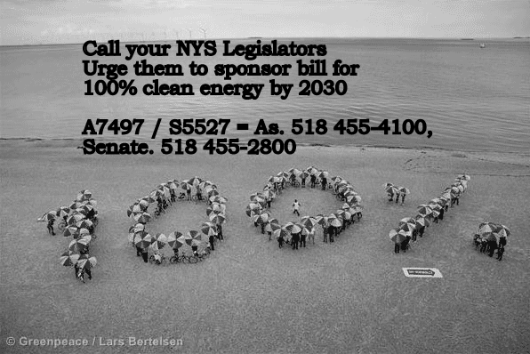

Act Now for a Healthier, More Sustainable Future

Tell elected officials at all levels to embrace a green future - 100% clean energy by 2030. In NYS, pass A7497 / S5527. Take steps in your own life to go to 100% clean energy (solarize, reduce, energy efficiency, mass transit, organic agriculture).
Campaign for 100% Clean Energy by 2030, c/o Green Education and Legal Fund, www.gelfny.org

